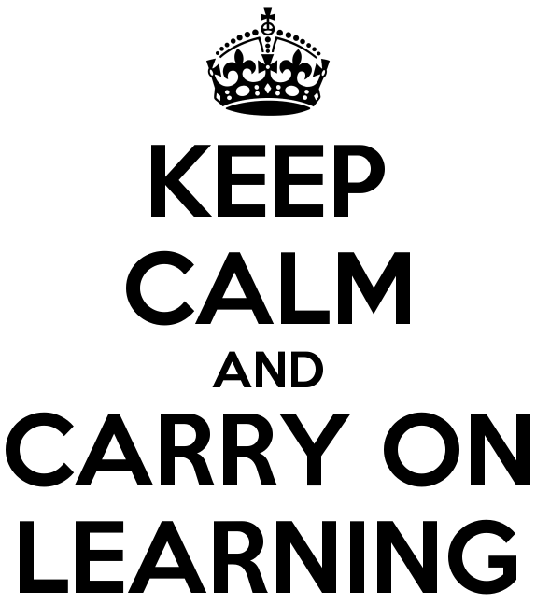

TT Rockstars
Timestables Rockstars will be available for the children to improve and work on their timestables as well as challenge others to Rock Slams and Battles against other Year groups.
My Maths
The children have all been shown how to use MyMaths, their pack includes a letter about how to access the website.
Twinkl
Twinkl have kindly offered to make all their resources free – go to www.twinkl.co.uk/offer and enter the code UKTWINKLHELPS.
Code
Code.org is another resource that the children can use and gives them access to a range of coding activities that they have accessed in the classroom.
Pobble
Pobble365.org has daily writing activities that the children can use as a stimulus for writing.
Other free online resources
Khan Academy
https://www.khanacademy.org
Especially good for maths and computing for all ages but other subjects at Secondary level. Note this uses the U.S. grade system but it's mostly common material.

BBC Learning
http://www.bbc.co.uk/learning/coursesearch/
This site is old and no longer updated and yet there's so much still available, from language learning to BBC Bitesize for revision. No TV licence required except for content on BBC iPlayer.

Seneca
https://www.senecalearning.com
For those revising at GCSE or A level. Tons of free revision content. Paid access to higher level material.

Openlearn
https://www.open.edu/openlearn/
Free taster courses aimed at those considering Open University but everyone can access it. Adult level, but some e.g. nature and environment courses could well be of interest to young people.

Blockly
https://blockly.games
Learn computer programming skills - fun and free.

Scratch
https://scratch.mit.edu/explore/projects/games/
Creative computer programming

Ted Ed
https://ed.ted.com
All sorts of engaging educational videos

National Geographic Kids
https://www.natgeokids.com/uk/
Activities and quizzes for younger kids.

Duolingo
https://www.duolingo.com
Learn languages for free. Web or app.

Mystery Science
https://mysteryscience.com
Free science lessons

The Kids Should See This
https://thekidshouldseethis.com
Wide range of cool educational videos

Crash Course
https://thecrashcourse.com
You Tube videos on many subjects

Crash Course Kids
https://m.youtube.com/user/crashcoursekids
As above for a younger audience

Crest Awards
https://www.crestawards.org
Science awards you can complete from home.

iDEA Awards
https://idea.org.uk
Digital enterprise award scheme you can complete online.

Paw Print Badges
https://www.pawprintbadges.co.uk
Free challenge packs and other downloads. Many activities can be completed indoors. Badges cost but are optional.

Cbeebies Radio
https://www.bbc.co.uk/cbeebies/radio
Listening activities for the younger ones.

Nature Detectives
https://naturedetectives.woodlandtrust.org.uk/naturedetectives/
A lot of these can be done in a garden, or if you can get to a remote forest location!

Oxford Owl for Home
https://www.oxfordowl.co.uk/for-home/
Lots of free resources for Primary age

Big History Project
https://www.bighistoryproject.com/home
Aimed at Secondary age. Multi disciplinary activities.

Geography Games
https://world-geography-games.com/world.html
Geography gaming!

Blue Peter Badges
https://www.bbc.co.uk/cbbc/joinin/about-blue-peter-badges
If you have a stamp and a nearby post box.

Red Ted Art
https://www.redtedart.com
Easy arts and crafts for little ones

The Imagination Tree
https://theimaginationtree.com
Creative art and craft activities for the very youngest.

Toy Theater
https://toytheater.com/
Educational online games

Early Years Reading
https://literacytrust.org.uk/early-years/
http://www.wordsforlife.org.uk/
https://small-talk.org.uk/
https://sfs.org.uk/resources/factsheets
https://www.booktrust.org.uk/books-and-reading/our-recommendations/best-books-for-0-5s
Writing
- Fun English Games: This website promotes children’s ability to debate. More suitable for Key Stage Two.
- Read for Good: On this website, children are able to create a short story that is fun and inspirational. From this, children can create extended adventures. This is suitable for all ages.
- ICT Games: This website has lots of exciting games for children who would like to practise their phonics and spelling of the high frequency words.
- Primary Homework Help: This brilliant resource covers many areas of English, such as spelling and phonics, reading, grammar, punctuation and writing for different text types

Spelling, Punctuation and Grammar (SPaG)
- Top Marks: The Topmarks website is safe and used in schools around the country and is great for English activities for Key Stage Two. It has fun games and activities to complete to help learn about Spelling, Punctuation and Grammar.
- Grammar, punctuation and spelling: This BBC website has a range of activities to help with Spelling, Punctuation and Grammar activities for Key Stage Two.
- Crickweb: The Crickweb website is great for a range of English activities for Key Stage One and Two. There are a selection of fun and interactive Spelling, Punctuation and Grammar activities for Key Stage One and Two.

Reading
- Oxford Owl: Oxford Owl has lots of hints and tips for reading with your child at home. There is also access to a fRee eBook library of 250 books, along with suggestions for reading books and kid’s activities.
- Love Reading 4 Kids: A great link for news on new books, recommendations and emphasising the importance of books in our modern world, where so much is digital.
- Top Marks: This site has many links to some great reading activities including comprehension, deduction, fiction and non-fiction in a fun way.

Maths
- BBC Bitesize - KS1These BBC Bitesize websites have a range of Maths activities for Key Stage One and Two. It has fun games and activities to complete to help learn about number, measure and geometry.
- BBC Bitesize - KS2These BBC Bitesize websites have a range of Maths activities for Key Stage One and Two. It has fun games and activities to complete to help learn about number, measure and geometry.
- Top Marks - The Topmarks website is safe and used in schools around the country for its great Maths activities. There are engaging games and interactive activities to help learn more about maths topics.
- Maths Zone - This website covers a lot of topics from our Maths lessons. It has great resources, activities and interactive questions to answer.
- Crickweb - This website is full of times tables questions and challenges so you can improve your speed!

Science
https://www.brainpop.com/

http://www.primaryhomeworkhelp.co.uk/revision/Science/

https://www.bbc.co.uk/bitesize/subjects/z2pfb9q

http://www.supascience.co.uk/

https://www.stem.org.uk/primary-science

